Backtesting Standard Operating Procedure (SOP)

1. Purpose
This document defines the standardized procedure for conducting historical backtesting using MetaTrader 5 (MT5), a custom data export Expert Advisor (EA), a Python-based machine learning backtesting model, and a dedicated MT5 execution EA (BackTester_EA.ex5).
The primary objective of this SOP is to ensure consistency, accuracy, and repeatability when:
- Extracting historical market data from MT5
- Generating machine learning–based trading signals
- Executing simulated trades in MT5 strictly based on those signals
Specifically, BackTester_EA.ex5 is responsible for placing trades in MT5 during Strategy Tester runs by reading the trading_signals.json file. Trades are executed only when:
- The candle date and time exactly match an entry in trading_signals.json, and
- The signal strength is Medium or Strong
All Weak signals are ignored.

2. Scope

This SOP applies to all analysts and developers performing strategy backtesting using a MetaTrader 5 (MT5)–based workflow integrated with a Python-driven machine learning signal generation process. This includes, but is not limited to:

3. Prerequisites
- MetaTrader 5 (MT5) installed and properly configured
- Access to MetaEditor
- Python installed with required dependencies
- Visual Studio Code (VS Code)
- Solara ML Expert Advisors and scripts correctly installed

4. Data Extraction from MT5

4.1 Select Currency Pair and Chart
- Identify the currency pair(s) to be backtested.
- Open the corresponding chart in MT5.

4.2 Run Data Export EA
- Attach the DataExports.mq5 EA to the selected chart by dragging and dropping it.
- EA file location:
- Advisors\Solara\ML\DataExporter\Exports\DataExports.ex5
- Configure the EA inputs:
- Select the required currency pairs
- Set the timeframe
- Define the historical date range
- Important: Do not modify any parameters related to technical indicators.

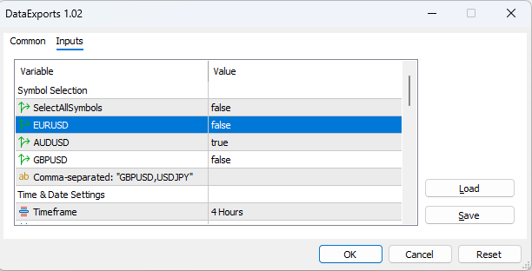

- If additional currency pairs are required, add them via MetaEditor.
- Click OK to execute the EA.

4.3 Confirm Export Completion
- A pop-up notification will confirm that the data export has completed successfully.

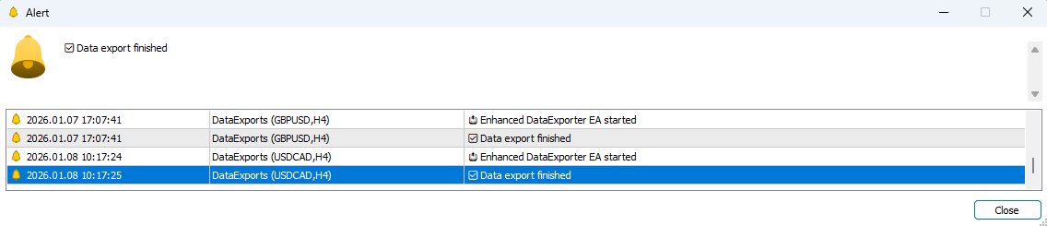

4.4 Locate Exported Files
All generated CSV files are stored in the following directory:
C:\Users\<USERNAME>\AppData\Roaming\MetaQuotes\Terminal\<TERMINAL_ID>\MQL5\Files\
These CSV files contain historical OHLCV data along with pre-calculated technical indicators required by the machine learning model.

4.5 Prepare CSV for Backtesting
- Move the selected CSV file to the following directory:
- C:\Users\<USERNAME>\AppData\Roaming\MetaQuotes\Terminal\<TERMINAL_ID>\MQL5\Experts\Advisors\Solara\BackTesting\
- Rename the CSV file as needed.
Sample CSV Output
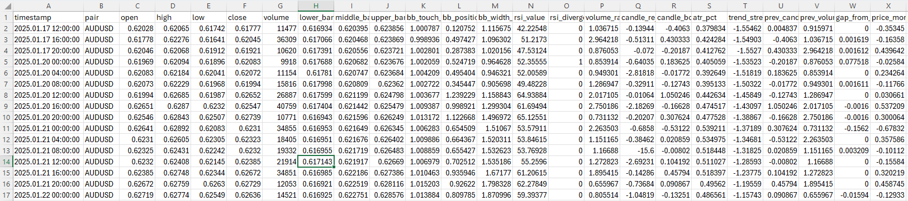

5. Machine Learning Model Execution

5.1 Configure the Model
- Open Visual Studio Code.
- Load BackTester_Model.py.
- Update the input_csv variable to match the selected CSV filename.

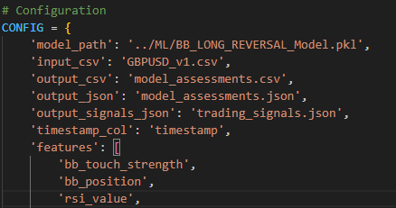

5.2 Run the Model
- Open the VS Code terminal.
- Execute:
- python backtester_model.py

5.3 Model Processing Logic
- The model analyzes historical market data and identifies potential trade entries and exits.
- Only Medium and Strong signals are considered valid for execution.
- Weak signals are explicitly excluded from all backtesting activity.

5.4 Model Output Files
The model generates the following JSON files: - model_assessments.json – Full model output including metadata - trading_signals.json – Medium and Strong trade signals only - model_summary.json – Performance statistics and evaluation metrics
Note: Only trading_signals.json is required for MT5 strategy execution.

6. Strategy Tester Execution in MT5

6.1 Configure Strategy Tester
- Open the Strategy Tester window in MT5.
- Select BackTester_EA.ex5.
- Set the symbol to match the currency pair used during data extraction.
- Adjust the timeframe if required.
- Set the testing date range (default: 1 year for initial evaluation).
- Set the modeling method to: Every tick based on real ticks.

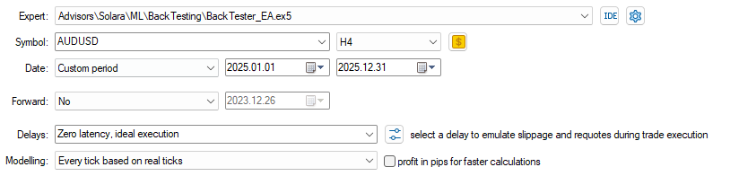

6.2 Configure EA Inputs
Modify the following parameters as required: - Lot size - Stop Loss - Take Profit

6.3 Initial Execution Behavior
- Click Start to begin the backtest.
- On the first execution, no trades will be placed if trading_signals.json is not yet present in the tester file directory.

7. Trading Signals File Placement

7.1 Default Tester File Path
During Strategy Tester execution, MT5 reads external files from the Tester directory. The commonly used file path for trading_signals.json is:
C:\Users\<USERNAME>\AppData\Roaming\MetaQuotes\Tester\<TERMINAL_ID>\Agent-127.0.0.1-3000\MQL5\Files
Notes: - <USERNAME>, <TERMINAL_ID>, and Agent-* values may vary depending on the system and testing agent. - This directory is the authoritative location where BackTester_EA.ex5 expects trading_signals.json during Strategy Tester execution.
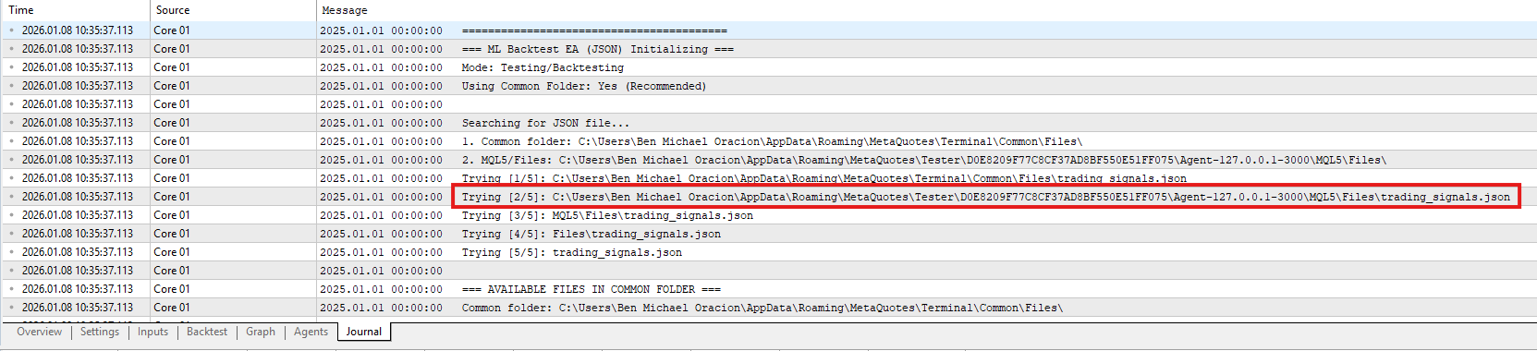

7.2 Locate the Exact Tester Directory
- Open the Journal tab in MT5 after running the Strategy Tester.
- Identify the log entry containing a file path with the keyword “Tester”.
- Copy the full path from the log.
- Paste it into File Explorer to open the correct directory.

7.3 Deploy Trading Signals
- Copy trading_signals.json into the identified Tester directory.
- Re-run BackTester_EA.ex5 in the Strategy Tester.

8. Trade Execution Logic (BackTester_EA.ex5)
During backtesting, BackTester_EA.ex5 operates as follows: - Reads trading_signals.json from the Tester directory - Matches each signal’s date and time against the current candle - Executes trades only when: - Date and time match exactly - Signal strength is Medium or Strong
Signals that do not meet these conditions are ignored.

9. Results Review
- Backtest results are displayed in the Backtest tab of the Strategy Tester
- Review performance metrics, trade history, equity curve, and drawdown as required

10. Completion
This concludes the standard operating procedure for conducting backtesting using the Solara ML framework. All steps must be followed sequentially to ensure accurate, reproducible, and auditable backtesting results.

